Use Cases to accelerate, by applying the learnings from Lead beyond Boundaries Workshop

Purpose –
To apply the learnings from the Lead Beyond Boundaries workshop to develop a strategic leadership mindset aligned with organizational priorities and measurable outcomes.

EDO Objectives 2026 -
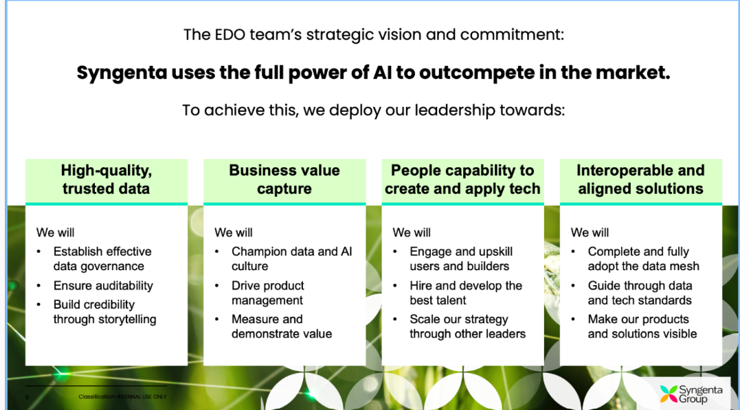

Team 6 – Manoj, Lalit, Pratik, Chetan, Mangesh, Sanjay
Use Case –
Scale AI Adoption Across Digital Agtech in a sustenable way
- Each Team adapts to usage of AI Tools effectively
- Teams evolves their ways of working such that we see end impact on productivity and quality
- Ensure psychological safety for people
EDO Objectives to focus –
- AI Adoption at Scale
- Tangible improvements in quality and productivity (Delivery)
- Scale the strategy through other leaders
- Establish effective Governance

Learnings to focus
- Loyal Soldier vs Growth Partners ( while working with Stakeholders )
- Visualize – Think Bigger Picture , Impact
- Anticipate and Ask - emerging patterns

Success Criteria ( KPI ) -
- Uniform adoption across scrum teams.
- Measurable Impact on ways of working, delivery metrics and quality metrics.
- Stakeholders feedback during the initiative
  - Andre
  - Uday

